

**Assignment Of**

**ITEC-515 DB Administration & Management**

**Practice Task-5**

**Submitted To:**

**Sir.Kamran Dahiri**

**Professor Dept:**

**Information Technology**

**Submitted By:**

**Mubashir Ali S/O**

**Mansoor Ali**

**(2k20/ITE/73) Group(A)**

**Lab Practice 5– Database Systems**

**Practice Question 1**

Write SQL query to show following output from **EMPLOYEES** and **DEPARTMENTS** tables using equi-join

**See output below**

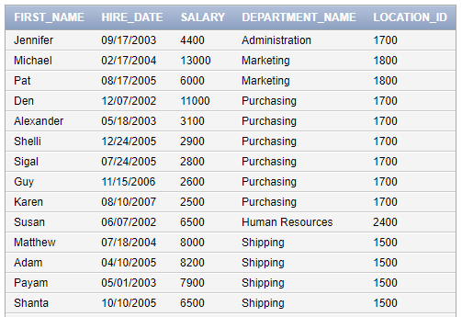

….

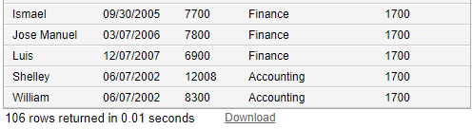

**Answer:**

SELECT E.FIRST_NAME,E.HIRE_DATE,E.SALARY,D.DEPARTMENT_NAME,D.LOCATION_ID

FROM EMPLOYEES E, DEPARTMENTS D

WHERE E.DEPARTMENT_ID = D.DEPARTMENT_ID;

**Practice Question 2**

Write SQL query to show following output from **EMPLOYEES, DEPARTMENTS** and **LOCATIONS** tables using **equi-join**

**See output below**

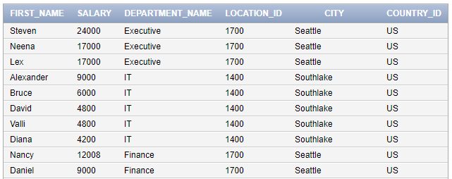

….

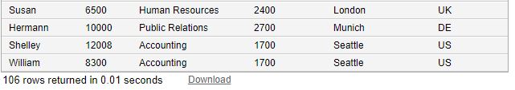

**Answer:**

SELECT DISTINCT E.FIRST_NAME,E.SALARY,DEPARTMENT_NAME,D.LOCATION_ID,CITY,L.COUNTRY_ID

FROM EMPLOYEES E, DEPARTMENTS D,LOCATIONS L

WHERE E.DEPARTMENT_ID = D.DEPARTMENT_ID

AND D.DEPARTMENT_NAME IN ('EXECUTIVE','IT','FINANCE','HUMAN RESOURCES','PUBLIC REALATIONS','ACCOUNTING')

AND L.COUNTRY_ID IN ('US','UK','DE');

**Practice Question 3**

Write SQL query to show following output from **COUNTRIES** and **REGIONS** tables using **INNER JOIN**

**See output below**

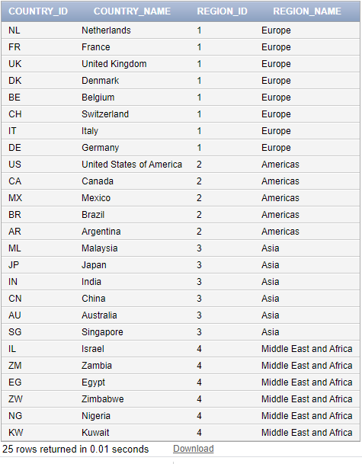

**Answer:**

SELECT COUNTRY_ID,COUNTRY_NAME,REGION_ID,REGION_NAME

FROM COUNTRIES

NATURAL JOIN REGIONS;

**Practice Question 4**

Write SQL query to show following output from **LOCATIONS**, **COUNTRIES** and **REGIONS** tables using **INNER JOIN** (**hint: use two inner joins**)

**See output below** 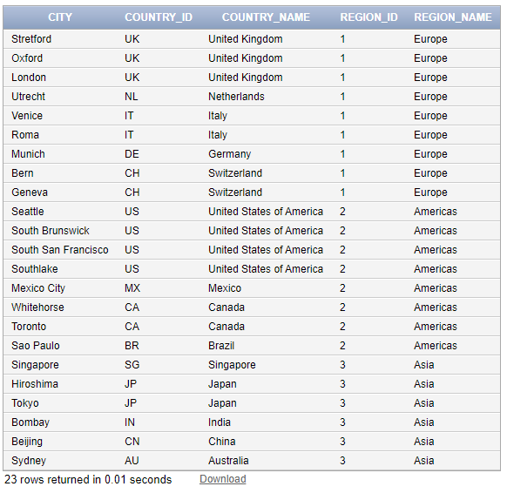

**Answer:**

SELECT DISTINCT LOCATIONS.CITY, COUNTRIES.COUNTRY_ID, COUNTRIES.COUNTRY_NAME,REGIONS.REGION_ID,REGIONS.REGION_NAME FROM LOCATIONS

INNER JOIN COUNTRIES

ON LOCATIONS.COUNTRY_ID = COUNTRIES.COUNTRY_ID

INNER JOIN REGIONS

ON COUNTRIES.COUNTRY_ID = LOCATIONS.COUNTRY_ID

WHERE REGIONS.REGION_NAME IN ('EUROPE','AMERICAS','ASIA')

ORDER BY REGIONS.REGION_ID;

**Practice Question 5**

Write SQL query to do show **Cartesian Product** of **Employees**, **Departments** and **Locations** Tables.

**See output below**

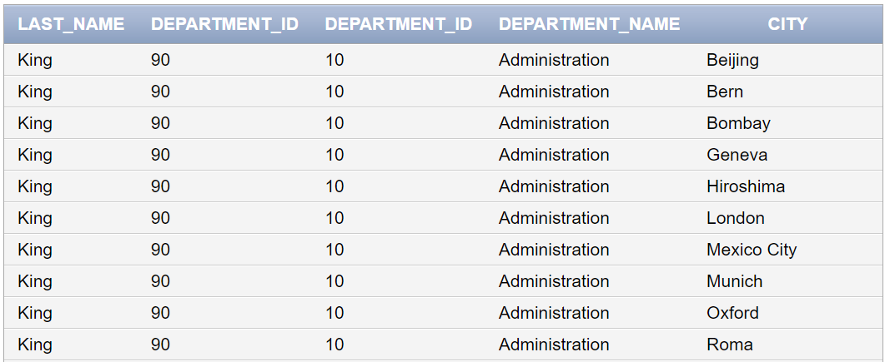

…

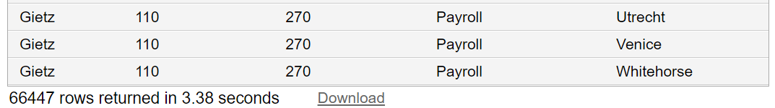

**Answer:**

SELECT LAST_NAME,EMPLOYEES.DEPARTMENT_ID,DEPARTMENTS.DEPARTMENT_ID,DEPARTMENT_NAME,CITY

FROM EMPLOYEES,DEPARTMENTS,LOCATIONS;

**Practice Question 6**

Write SQL query to do show **Employee’s Last Names** whose name start with ‘**K**’ also show and **Department Names** against each name of employee

(Hint: Use Joining between **Employees** and **Departments** tables and also apply condition)

**For details see output below**

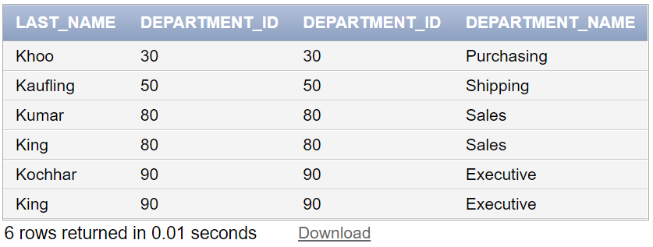

**Answer:**

SELECT LAST_NAME,EMPLOYEES.DEPARTMENT_ID,DEPARTMENTS.DEPARTMENT_ID, DEPARTMENT_NAME

FROM EMPLOYEES, DEPARTMENTS

WHERE EMPLOYEES.DEPARTMENT_ID = DEPARTMENTS.DEPARTMENT_ID

AND LAST_NAME LIKE 'K%';

**THE END**